**OBJECTIVE FUNCTION OF RPL USING A COMPOSITE METRIC**

**Software Requirements:**

Operating System : Ubuntu 14.04 LTS 64bit, Vmware Player 16.1.0, Instant contiki-3.0 Simulator: Cooja

Language : C

**Simulation Model:**

|  |  |
| --- | --- |
| Simulator | Cooja |
| Number of Nodes | 25,50 nodes. |
| Routing Protocol | RPL protocol |
| Transmission Range | 50m |
| Area | 300m * 300m |
| Simulation Time | 300 seconds |
| Objective function | MRHOF,OF0 |
| Radio Medium Model | UDGM-distance loss |
| Mote Type | Sky |
| Topology | Random |

**Network model:**

**Topology:** Random topology

**Total Simulation time**: 300 seconds

* **Server node**
* **Client node**

**No.of.Nodes25**

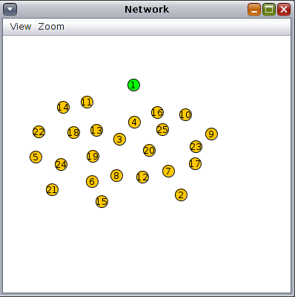

**No.of.Nodes50** 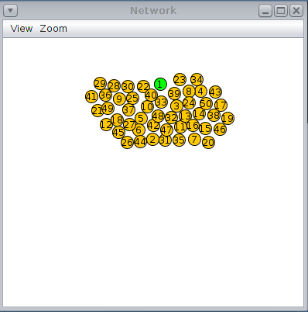

**Simulation**

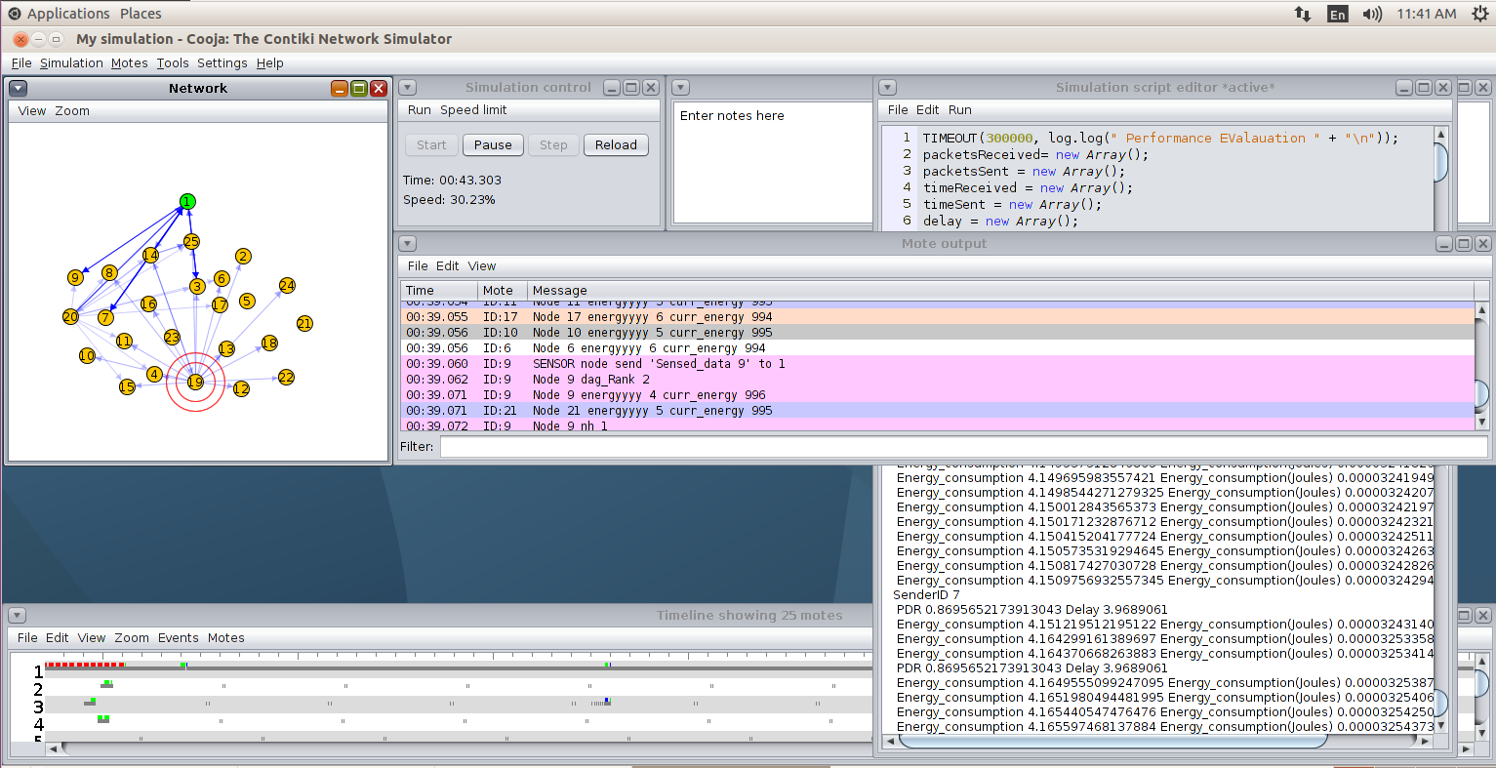Each RPL node has its predefined objective function (OF), this function carries the metrics upon which nodes select the better parent among competing nodes. There are currently two objective functions presented by the IETF, the first one is Objective Function zero (OF0) which is a simple and basic objective function that has only one metric, it uses hop count to the root as rank of the node to determine its distance from the root and selects the node with the lower (better) rank. The OF0 is designed as a general objective function used as a guide and base for other implementations. The second and the more popular one is the minimum rank with hysteresis objective function (MRHOF). This function uses the expected transmission count (ETX) as the default metric.

**Screenshots Explanation:**

1. **ETX CALCULATION(rpl-mrhof.c)**

ETX (Ni) = 1 / (PDR s−>d∗PDR d->s)

ETX is a link reliability metric. It is the expected number of transmissions required for a data packet to be delivered successfully.

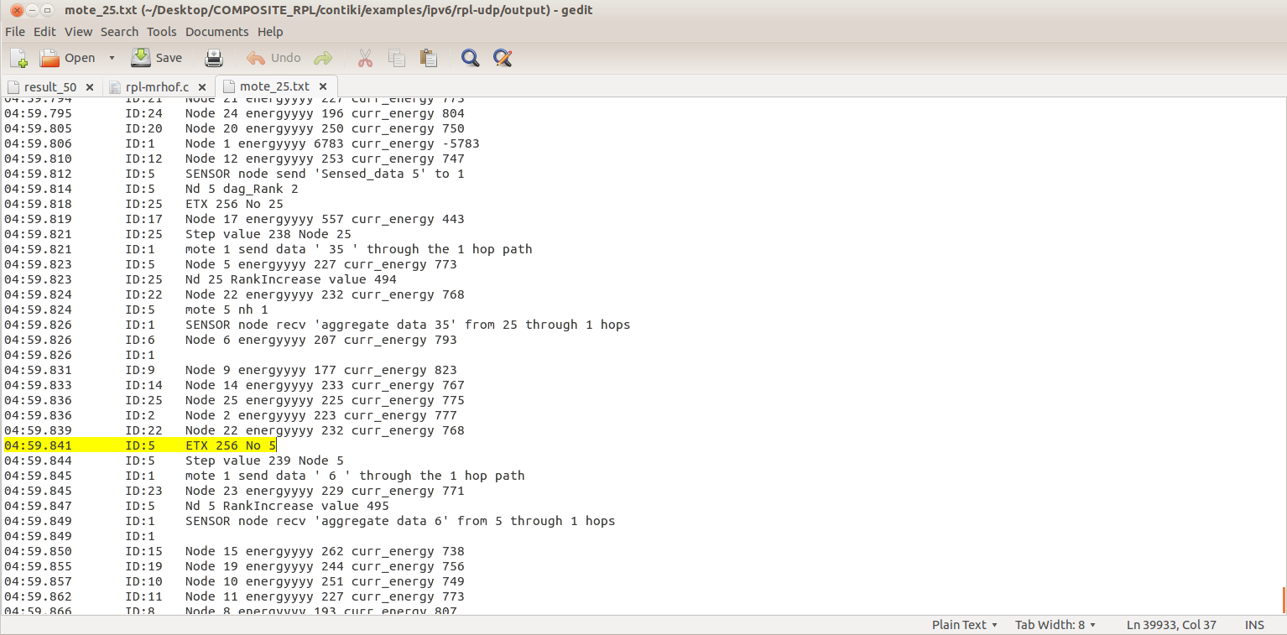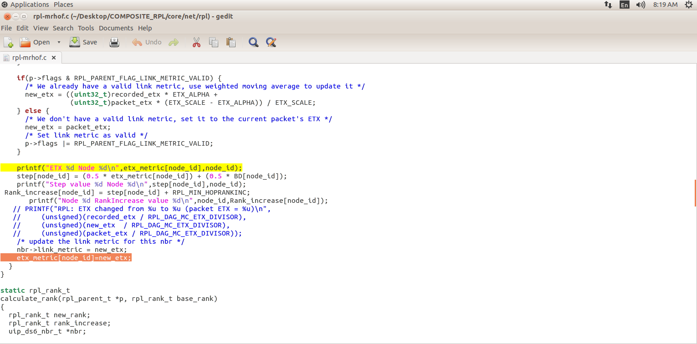

1. **BDI CALCULATION(rpl-icmp6.c)**

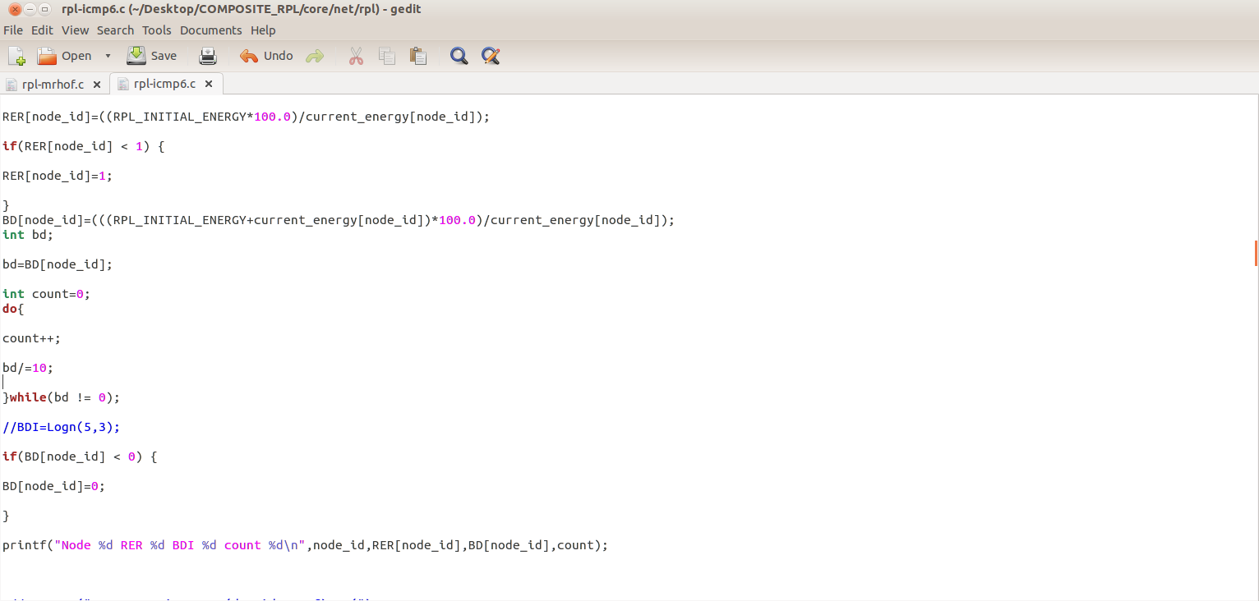

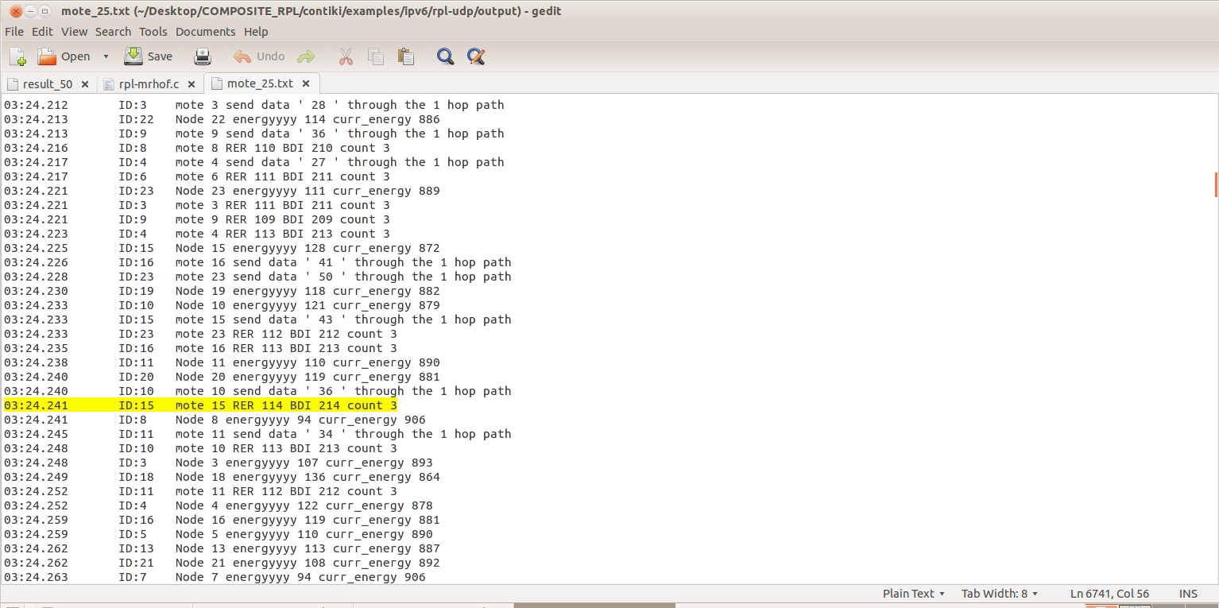

EC(i) = Time(Tx) * Power(Tx) + Time(Rx) * Power(Rx) + Time(CPU) * Power(CPU) + Time(LPM) * Power(LPM)

This metric indicates the percentage of energy depleted from the node’s battery. It is calculated from the energy consumed (EC) by the node from the beginning of its operation. Energy consumption by the node i EC(i) can be calculated based on the power consumed by the node in each of the four possible states in which the node can operate.

1. **RANK CALCULATION**

**Rpl-mrhof.f**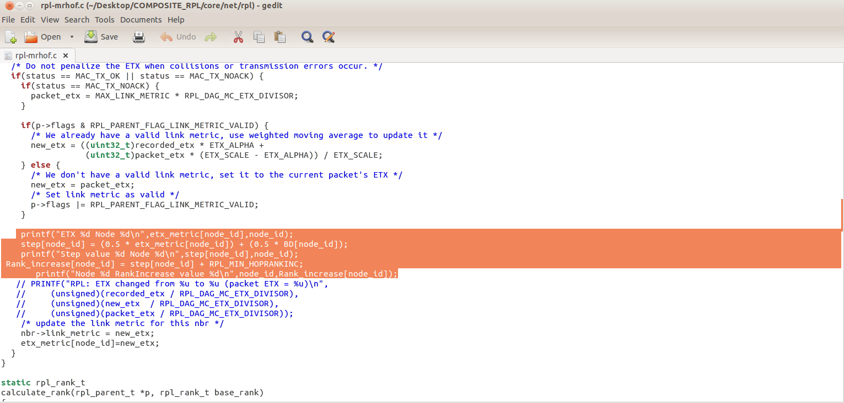

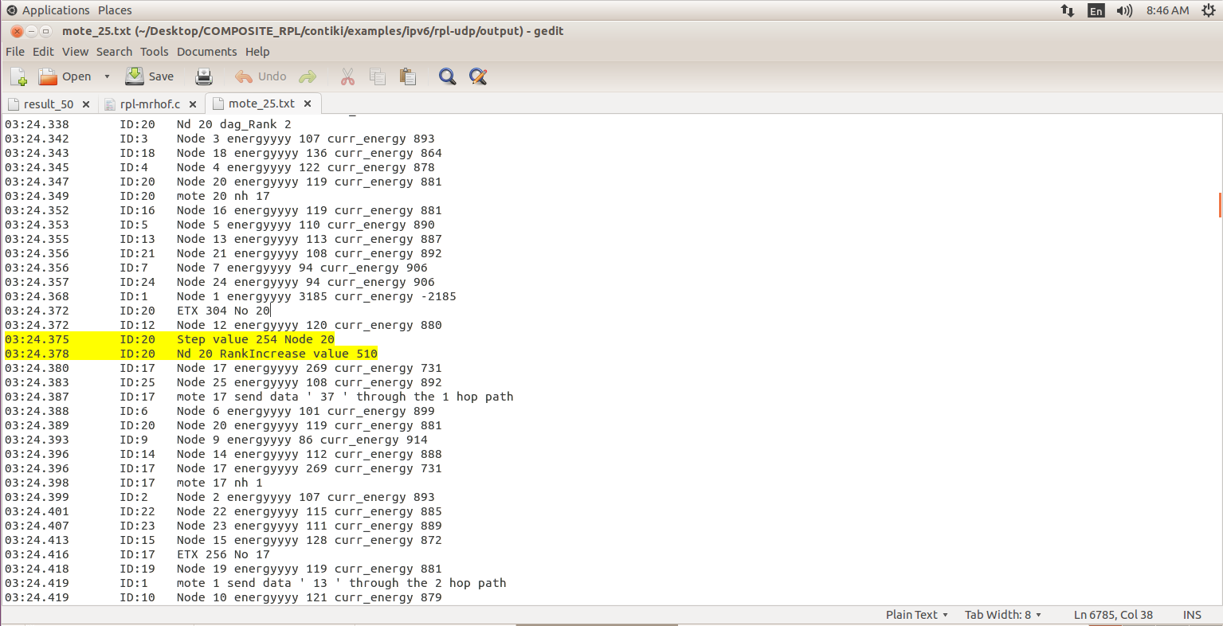

**Udp-client.c**

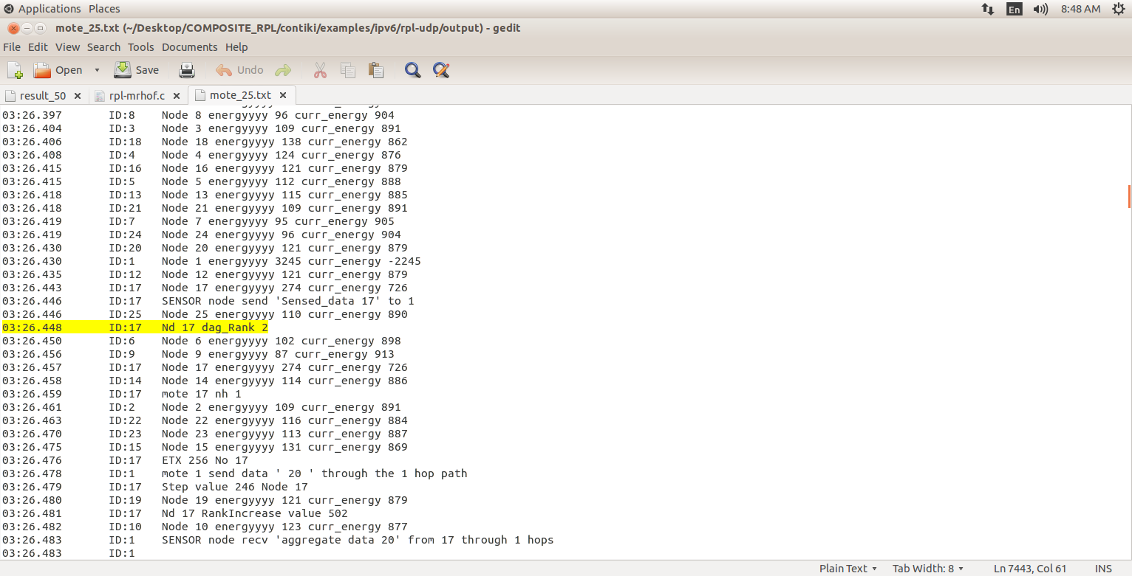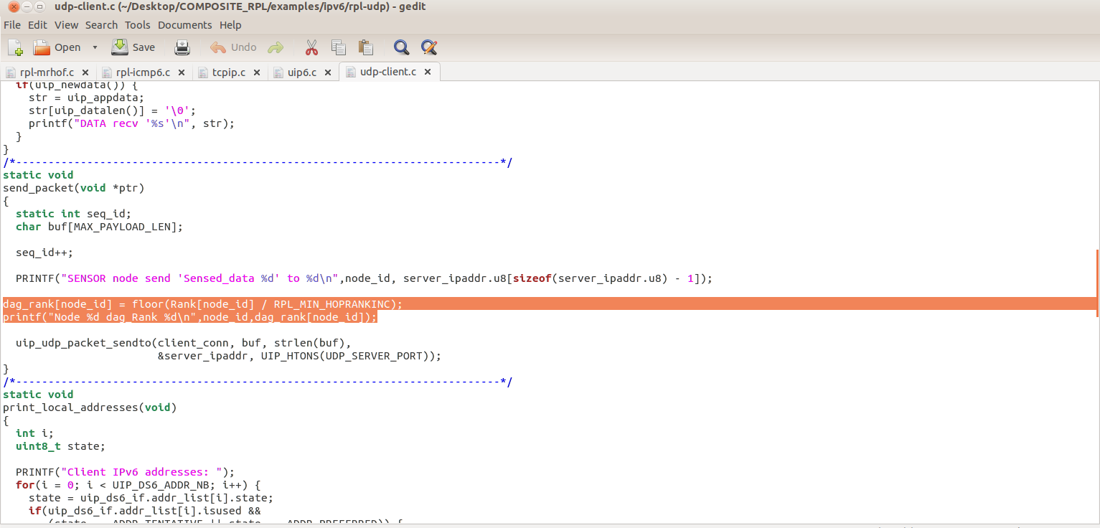

The parent selection is based on DODAG rank of the candidate parent nodes. The DODAG rank is calculated from parent rank and rank increase value. The rank increase is calculated from the objective function step value and MinHopRankIncrease. (Default value of MinHopRankIncrease = 256).

Step = w1* ETX + w2* BDI

Rank_Increase = Step + MinHopRankIncrease

Rank(N) = Rank(Parent node) + Rank_Increase

DAGRank(N) = floor( Rank(N) / MinHopRankIncrease)

**ENERGY CALCULATION(tcpip.c)**

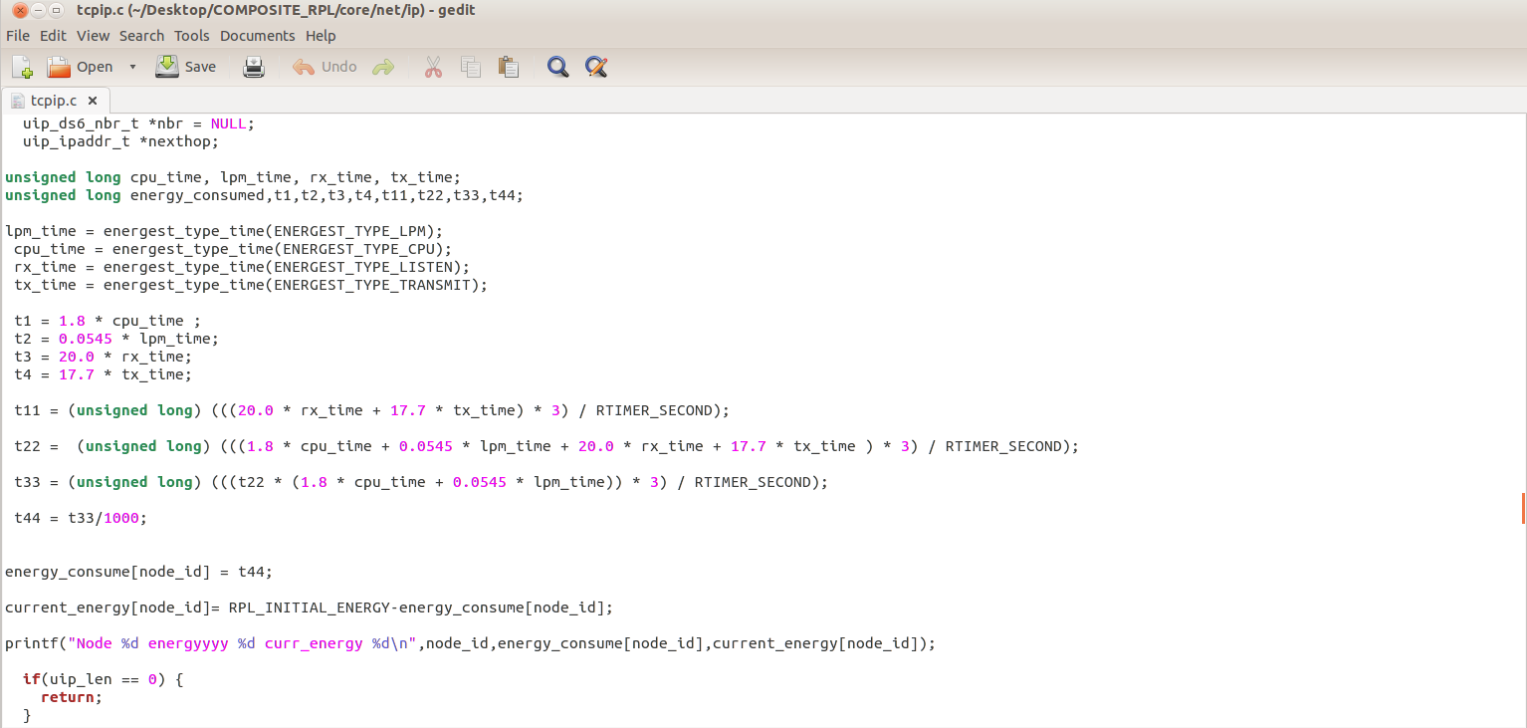**DATA SEND(udp-client.c)**

Each client node send data packets to the server.

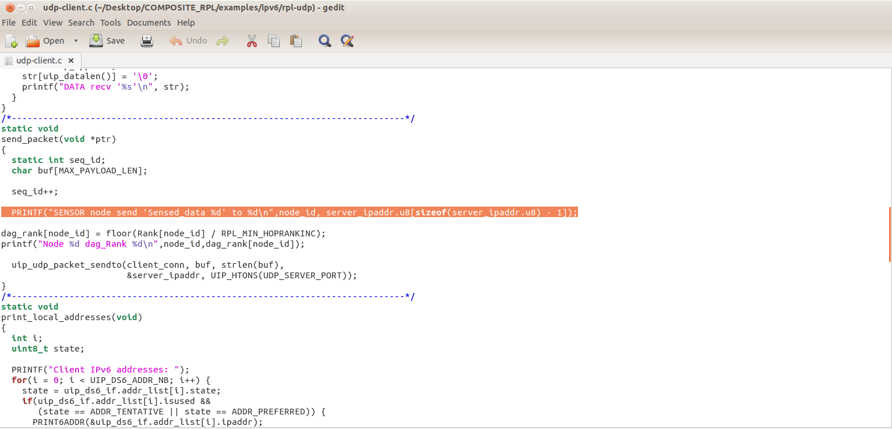

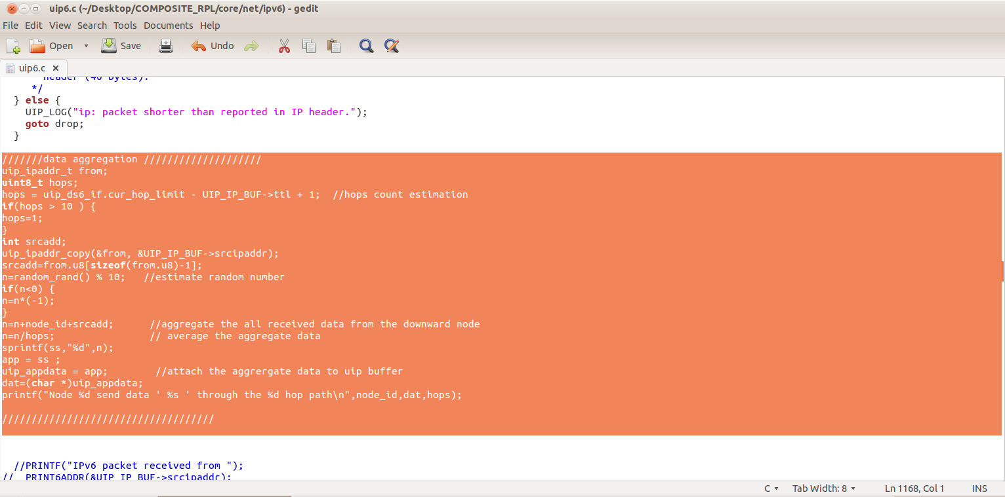

**DATA RECEIVE(udp-server.c)**

Server node will receive all data packets from sensor nodes.

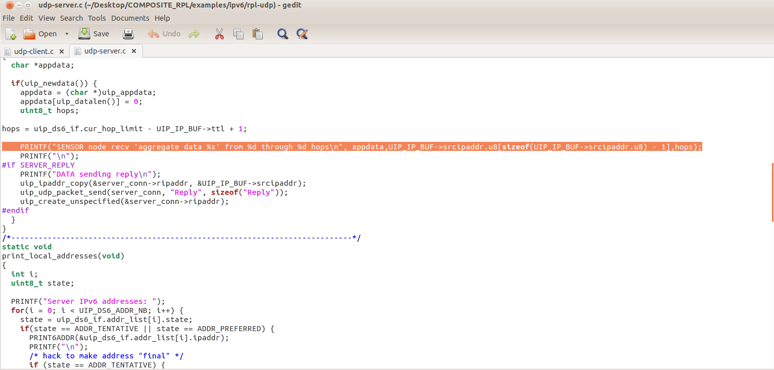

**Performance metrics:**

1. **Packet delivery ratio**

The ratio between total sent packets to the total received packets.

1. **Delay**

It is the time taken between total received time to the total sent time.

**3.Energy Consumption**

Energy consumption is the amount of energy or power used to transmit or receive data packets.